FINAL DATA BASE PROJECT
ACESS
OZAN KURBAN

TASK 1:Entity Relationship Diagram (ERD)
Demonstrate your understanding of database structure and design by creating a detailed ERD that accurately represents your grading database.
Instructions
- Use Lucidchart to create your ERD.
- Include:
  - All tables in your grading database
  - Primary keys and data types
  - Relationships between tables
  - Cardinality and participation constraints (make sure to include minimum and maximum)
Submission Format
Export your ERD as an image (PNG or JPEG). Paste it directly into your PDF under Task 1, labeled as:
Figure 1. Entity Relationship Diagram of the Grading Database.

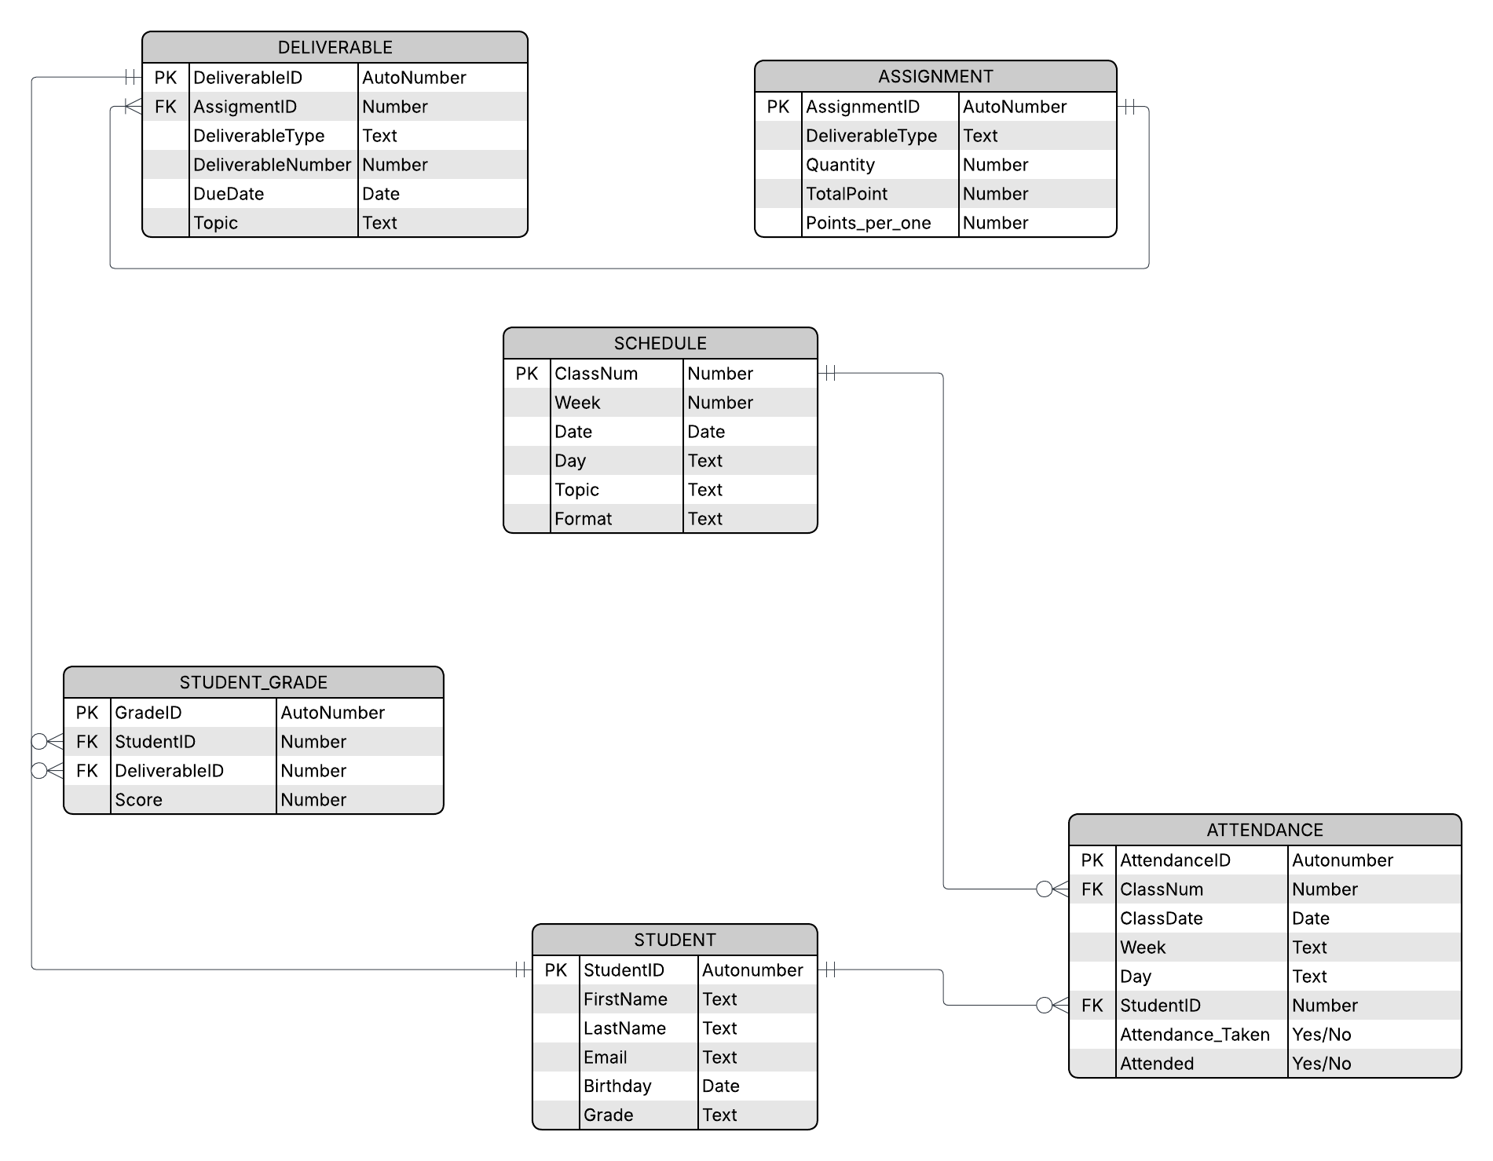

TASK2:SQL Table Creation Code
Translate your conceptual database design into SQL schema code.
Instructions
- Use Lucidchart’s export function (you can use AI to modify the SQL syntax to MS Access)
- Include table names, fields, data types, keys, and constraints.

Original Code:
CREATE TABLE `STUDENT` (
`StudentID` Autonumber,
`FirstName` Text,
`LastName` Text,
`Email` Text,
`Birthday` Date,
`Grade` Text,
PRIMARY KEY (`StudentID`)
);

CREATE TABLE `SCHEDULE` (
`ClassNum` Number,
`Week` Number,
`Date` Date,
`Day` Text,
`Topic` Text,
`Format` Text,
PRIMARY KEY (`ClassNum`)
);

CREATE TABLE `ATTENDANCE` (
`AttendanceID` Autonumber,
`ClassNum` Number,
`ClassDate` Date,
`Week` Text,
`Day` Text,
`StudentID` Number,
`Attendance_Taken` Yes/No,
`Attended` Yes/No,
PRIMARY KEY (`AttendanceID`),
FOREIGN KEY (`StudentID`)
REFERENCES `STUDENT`(`StudentID`),
FOREIGN KEY (`ClassNum`)
REFERENCES `SCHEDULE`(`ClassNum`)
);

CREATE TABLE `ASSIGNMENT` (
`AssignmentID` AutoNumber,
`DeliverableType` Text,
`Quantity` Number,
`TotalPoint` Number,
`Points_per_one` Calculated,
PRIMARY KEY (`AssignmentID`)
);

CREATE TABLE `DELIVERABLE` (
`DeliverableID` AutoNumber,
`AssigmentID` Number,
`DeliverableType` Text,
`DeliverableNumber` Number,
`DueDate` Date,
`Topic` Text,
PRIMARY KEY (`DeliverableID`),
FOREIGN KEY (`AssigmentID`)
REFERENCES `ASSIGNMENT`(`AssignmentID`)
);

CREATE TABLE `STUDENT_GRADE` (
`GradeID` AutoNumber,
`StudentID` Number,
`DeliverableID` Number,
`Score` Number,
PRIMARY KEY (`GradeID`),
FOREIGN KEY (`StudentID`)
REFERENCES `STUDENT`(`StudentID`),
FOREIGN KEY (`DeliverableID`)
REFERENCES `DELIVERABLE`(`DeliverableID`)
);
Optimized Access SQL:
CREATE TABLE `STUDENT` (
`StudentID` COUNTER,
`FirstName` VARCHAR(50),
`LastName` VARCHAR(50),
`Email` VARCHAR(100),
`Birthday` DATETIME,
`Grade` VARCHAR(10),
CONSTRAINT PK_STUDENT PRIMARY KEY (`StudentID`)
);

CREATE TABLE `SCHEDULE` (
`ClassNum` INTEGER,
`Week` INTEGER,
`Date` DATETIME,
`Day` VARCHAR(15),
`Topic` VARCHAR(255),
`Format` VARCHAR(50),
CONSTRAINT PK_SCHEDULE PRIMARY KEY (`ClassNum`)
);

CREATE TABLE `ATTENDANCE` (
`AttendanceID` COUNTER,
`ClassNum` INTEGER,
`ClassDate` DATETIME,
`Week` VARCHAR(50),
`Day` VARCHAR(20),
`StudentID` INTEGER,
`Attendance_Taken` YESNO,
`Attended` YESNO,
CONSTRAINT PK_ATTENDANCE PRIMARY KEY (`AttendanceID`),
CONSTRAINT FK_ATT_STUDENT FOREIGN KEY (`StudentID`) REFERENCES `STUDENT`(`StudentID`),
CONSTRAINT FK_ATT_SCHEDULE FOREIGN KEY (`ClassNum`) REFERENCES `SCHEDULE`(`ClassNum`)
);
CREATE TABLE `ASSIGNMENT` (
`AssignmentID` COUNTER,
`DeliverableType` VARCHAR(50),
`Quantity` INTEGER,
`TotalPoint` DOUBLE,
`Points_per_one` DOUBLE, -- Sayı (Ondalıklı olabilir diye DOUBLE seçtik)
CONSTRAINT PK_ASSIGNMENT PRIMARY KEY (`AssignmentID`)
);
CREATE TABLE `DELIVERABLE` (
`DeliverableID` COUNTER,
`AssignmentID` INTEGER,
`DeliverableType` VARCHAR(50),
`DeliverableNumber` INTEGER,
`DueDate` DATETIME,
`Topic` VARCHAR(255),
CONSTRAINT PK_DELIVERABLE PRIMARY KEY (`DeliverableID`),
CONSTRAINT FK_DELIV_ASSIGN FOREIGN KEY (`AssignmentID`) REFERENCES `ASSIGNMENT`(`AssignmentID`)
);
CREATE TABLE `STUDENT_GRADE` (
`GradeID` COUNTER,
`StudentID` INTEGER,
`DeliverableID` INTEGER,
`Score` DOUBLE,
CONSTRAINT PK_STUDENT_GRADE PRIMARY KEY (`GradeID`),
CONSTRAINT FK_GRADE_STUDENT FOREIGN KEY (`StudentID`) REFERENCES `STUDENT`(`StudentID`),
CONSTRAINT FK_GRADE_DELIV FOREIGN KEY (`DeliverableID`) REFERENCES `DELIVERABLE`(`DeliverableID`)
);
TASK 3:Attendance Query To Date
Aggregate and calculate student attendance percentage up to date . Do not include classes that were canceled, only classes where attendance was recorded.
Instructions
Create a query that outputs:
- Student Name
- Number of class attended
- Number of class not attended
- Attendance percentage
- Weighted Points (Max)
- Weighted Points Earned = (Attendance percentage × Weight)
Submission
- Part A – SQL Code (as text)
- Part B – Query Results Table (formatted)

For calculation of attendance percentage I found count of attendance
SELECT
ATTENDANCE.StudentID,
Count(ATTENDANCE.Attendance_Taken) AS CountOfAttendance_Taken
FROM
SCHEDULE
INNER JOIN ATTENDANCE ON SCHEDULE.ClassNum = ATTENDANCE.ClassNum
WHERE
(((ATTENDANCE.Attendance_Taken) = Yes))
GROUP BY
ATTENDANCE.StudentID
HAVING
(((ATTENDANCE.StudentID) = 1));
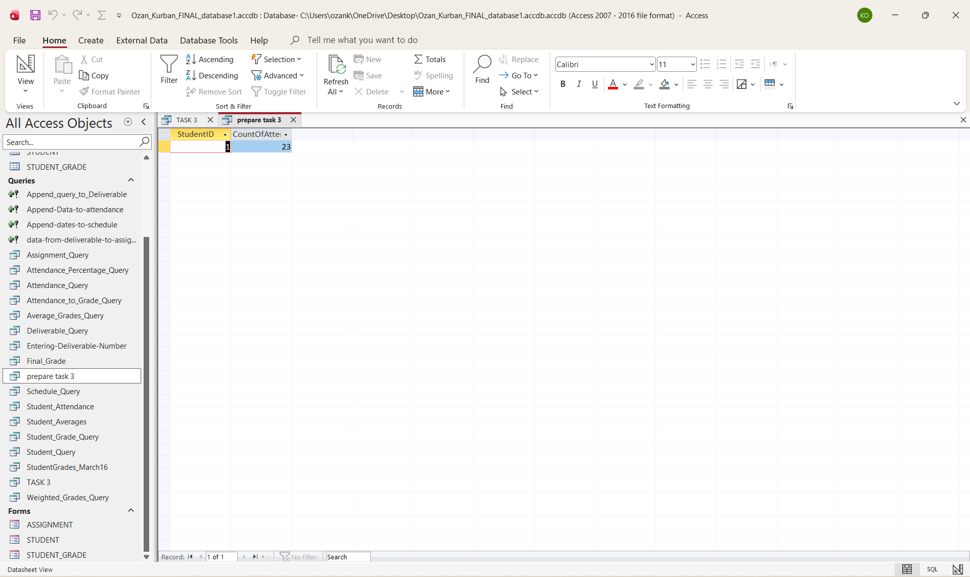
SELECT
S.FirstName & " " & S.LastName AS StudentName,
SUM(IIf(A.Attended = 'Yes', 1, 0)) AS ClassesAttended,
SUM(IIf(A.Attended = 'No', 1, 0)) AS ClassesNotAttended,
ROUND(
(
SUM(IIf(A.Attended = 'Yes', 1, 0)) * 1.0 / SUM(IIf(A.Attendance_Taken = 'Yes', 1, 0))
) * 100,
2
) AS AttendancePercent,
DLookup (
"TotalPoint",
"ASSIGNMENT",
"DeliverableType='Attendance'"
) AS WeightedPointsMax,
ROUND(
(
(
SUM(IIf(A.Attended = 'Yes', 1, 0)) * 1.0 / SUM(IIf(A.Attendance_Taken = 'Yes', 1, 0))
)
) * DLookup (
"TotalPoint",
"ASSIGNMENT",
"DeliverableType='Attendance'"
),
2
) AS WeightedPointsEarned
FROM
STUDENT AS S
INNER JOIN ATTENDANCE AS A ON S.StudentID = A.StudentID
WHERE
A.Attendance_Taken = 'Yes'
AND A.ClassDate <= #5 / 1 / 2026 #
GROUP BY
S.FirstName,
S.LastName
ORDER BY
S.LastName,
S.FirstName;

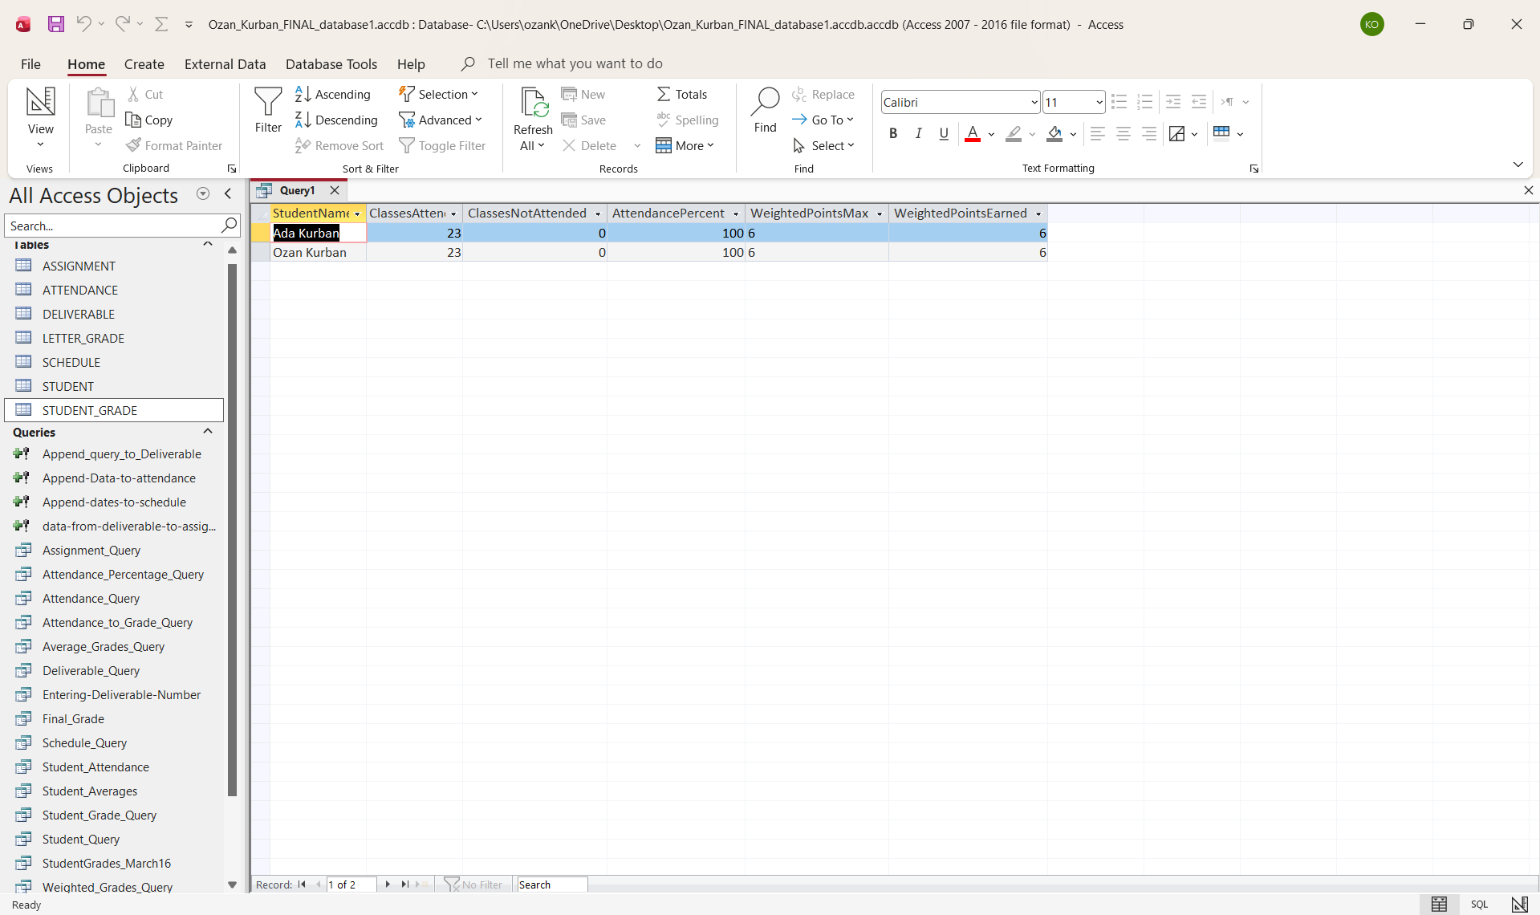
TASK 4:Append Attendance Score to the STUDENT_GRADE table
Once you calculate the student attendance percentages up to date (Tip - use 4/30/2026 as your cut-off date), append them to the STUDENT_GRADE table so they will be counted towards the final grade calculation.
Instructions
Create a query that appends:
- StudentID
- DeliverableID (hint -- from the weight table take the primary key for Participation or Attendance)
- Grade or score
Submission
- Part A – SQL Code (as text)
- Part B – Query Results Table (formatted)
- INSERT INTO STUDENT_GRADE (StudentID, DeliverableID, Score)
- SELECT
- S.StudentID,
- DLookup("AssignmentID","ASSIGNMENT","DeliverableType='Attendance'") AS DeliverableID,

- ROUND(
- (SUM(IIf(A.Attended='Yes',1,0)) * 1.0 /
- SUM(IIf(A.Attendance_Taken='Yes',1,0))) * 100
- , 2) AS AttendancePercentScore

- FROM
- STUDENT AS S
- INNER JOIN ATTENDANCE AS A
- ON S.StudentID = A.StudentID

- WHERE
- A.Attendance_Taken='Yes'
- AND A.ClassDate <= #4/30/2026#

- GROUP BY
- S.StudentID;

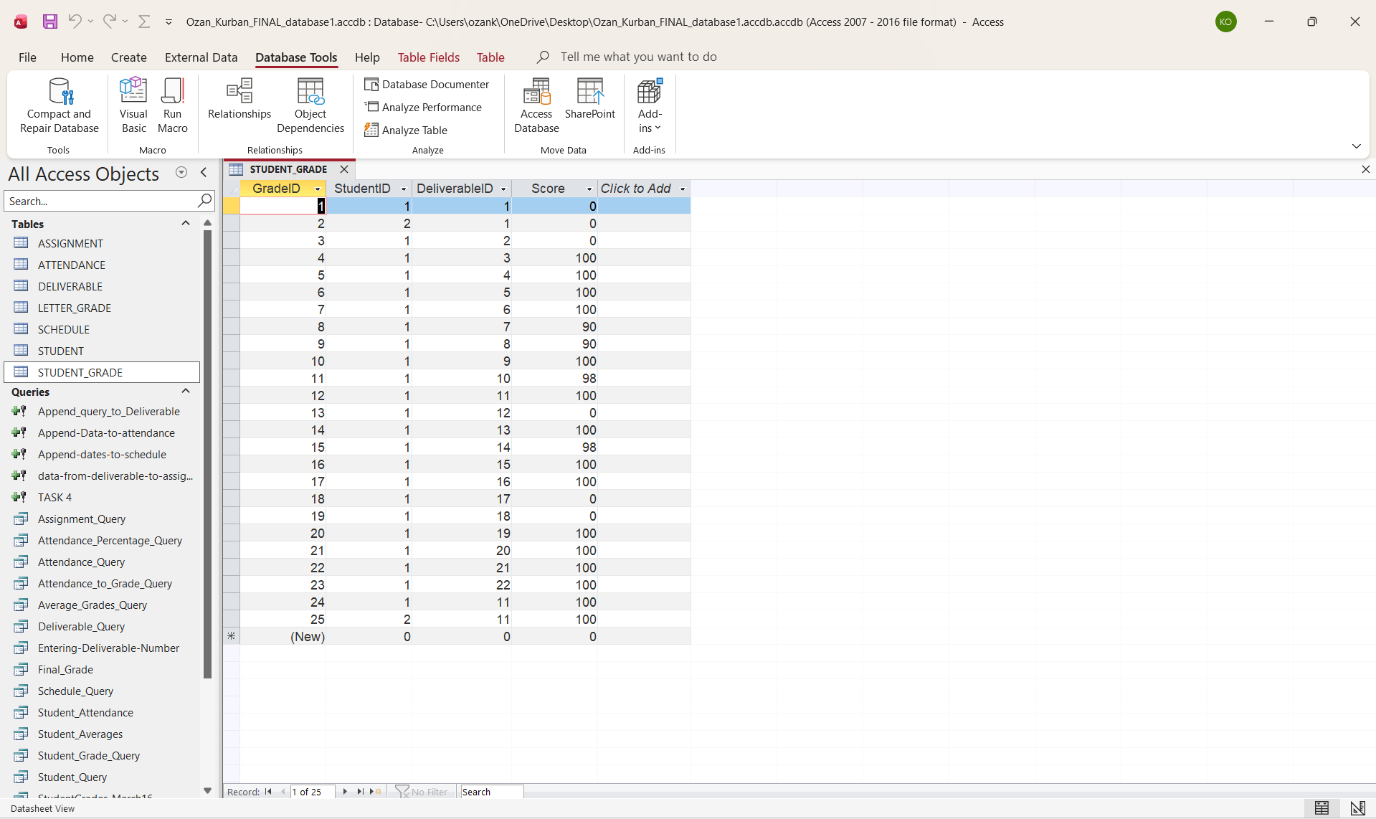

Deliverable Summary Query To Date
Aggregate and calculate student performance across multiple deliverable types up to date
Instructions
Create a query that outputs:
- Student Name
- Deliverable Type
- Quantity completed
- Average Score (using Date() for current cutoff)
- Weighted Points (Max)
- Weighted Points Earned = (Average × Weight)
Use appropriate JOIN and GROUP BY statements.
Submission
- Part A – SQL Code (as text)
- Part B – Query Results Table (formatted)
SELECT
S.FirstName & " " & S.LastName AS StudentName,
A2.DeliverableType,
COUNT(SG.Score) AS QuantityCompleted,
ROUND(AVG(SG.Score), 2) AS AverageScore,
A2.TotalPoint AS WeightedPointsMax,
ROUND( (AVG(SG.Score)/100) * A2.TotalPoint, 2 ) AS WeightedPointsEarned

FROM
(STUDENT AS S
INNER JOIN STUDENT_GRADE AS SG
ON S.StudentID = SG.StudentID)
INNER JOIN ASSIGNMENT AS A2
ON SG.DeliverableID = A2. AssignmentID

WHERE
SG.Score IS NOT NULL
AND (
SELECT MAX(D.DueDate)
FROM DELIVERABLE AS D
WHERE D.AssignmentID = A2.AssignmentID
) <= #4/30/2026#

GROUP BY
S.FirstName,
S.LastName,
A2.DeliverableType,
A2.TotalPoint

ORDER BY
S.LastName, S.FirstName, A2.DeliverableType;
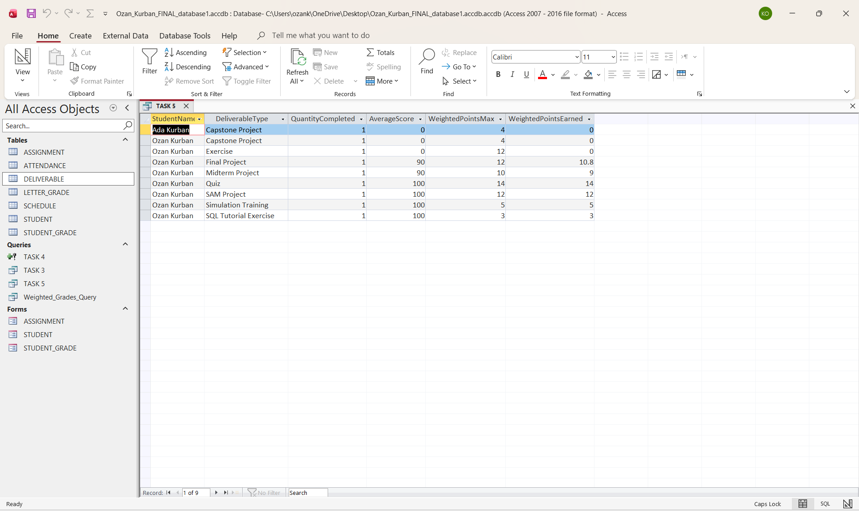
TASK 5:Final Grade Calculation Query (Up to Date)
Compute cumulative performance across deliverable types up to a date (May 1).
Instructions
- Use results from Task 3 as a base.
- Calculate each student’s final grade as the sum of weighted points earned.
- Format to two decimals.
- Include student names.
Submission
- Part A – SQL Code
- Part B – Final Grade Results Table
- Hint - make sure that you calculate the points you received up to date as a percentage of the total points available. It should not include the final test and project

SELECT
S.FirstName & " " & S.LastName AS StudentName,

ROUND(
SUM(
/* Weighted Points Earned for each deliverable type */
(SG.Score / 100.0) * A.TotalPoint
)
, 2) AS FinalGrade

FROM
(STUDENT AS S
INNER JOIN STUDENT_GRADE AS SG
ON S.StudentID = SG.StudentID)
INNER JOIN ASSIGNMENT AS A
ON SG.DeliverableID = A.AssignmentID

WHERE
/* Final Test ve Final Project dahil edilmez */
A.DeliverableType NOT IN ('Final Test', 'Final Project')

/* Cutoff: only deliverables with due dates up to May 1 */
AND SG.DeliverableID IN (
SELECT D.DeliverableID
FROM DELIVERABLE AS D
WHERE D.DueDate <= #5/1/2026#
)

GROUP BY
S.FirstName, S.LastName

ORDER BY
S.LastName, S.FirstName;
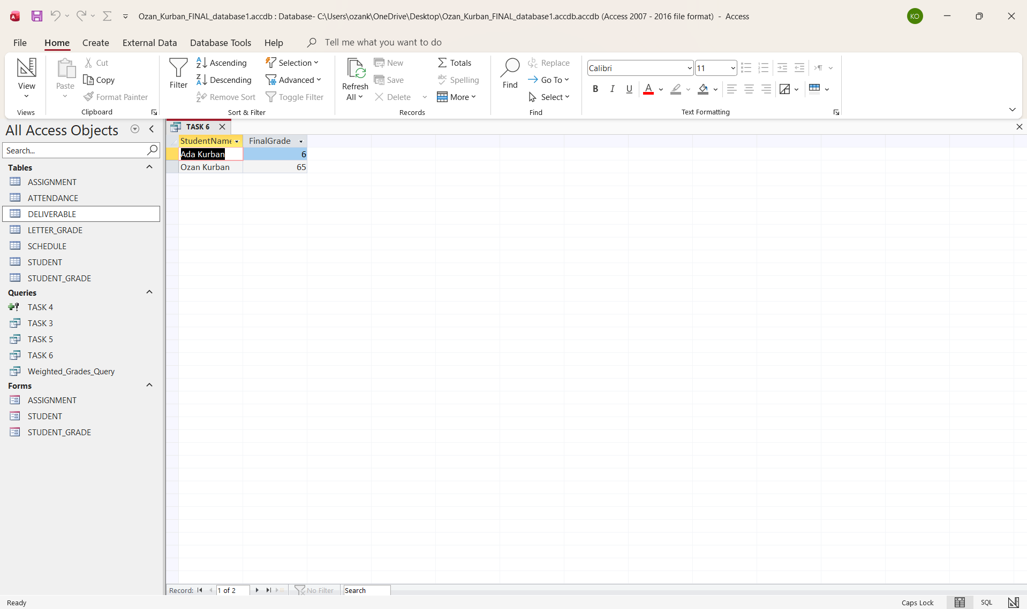
Letter Grade Calculation Queries
Map numeric grades to letter grades using a lookup table. Do it for your grade up to date.
Instructions
- Create a LETTER_GRADE_SCALE table:
  - MinScore, MaxScore, LetterGrade
- Populate it based on your grading scale.
- Join it to your final grade query using BETWEEN.
Submission
- Part A – SQL Code (join logic)
- Part B – Table of numeric and letter grades

SELECT
FG.StudentName,
FG.FGScore,
L.Grade AS LetterGrade
FROM
(
SELECT
S.FirstName & ' ' & S.LastName AS StudentName,
CDbl (ROUND(SUM((SG.Score / 100.0) * A.TotalPoint), 2)) AS FGScore
FROM
(
STUDENT AS S
INNER JOIN STUDENT_GRADE AS SG ON S.StudentID = SG.StudentID
)
INNER JOIN ASSIGNMENT AS A ON SG.DeliverableID = A.AssignmentID
WHERE
A.DeliverableType NOT IN ('Final Test', 'Final Project')
AND SG.DeliverableID IN (
SELECT
DeliverableID
FROM
DELIVERABLE
WHERE
DueDate <= #5 / 1 / 2026 #
)
GROUP BY
S.FirstName,
S.LastName
) AS FG
INNER JOIN LETTER_GRADE AS L ON FG.FGScore >= L.Min_Grade
AND FG.FGScore <= L.Max_Grade
ORDER BY
FG.StudentName

Minimum Grade Analysis
Estimate the lowest possible final grade if all missing work scores are zero (all ungraded work, like the final test and final project).
Instructions
- Replace all missing grades with 0.
- Include all deliverable types.
- Sum weighted scores with zeros.
- Output: Student Name and Minimum Possible Final Grade (2 decimals)
Submission
- Part A – SQL Code
- Part B – Results Table

SELECT
S.FirstName & ' ' & S.LastName AS StudentName,
ROUND(
SUM(Nz (SG.Score, 0) * A.Points_per_one) / (
SELECT
Max(Max_Grade)
FROM
LETTER_GRADE
),
2
) AS MinPossibleFinalGrade
FROM
(
(
STUDENT AS S
LEFT JOIN STUDENT_GRADE AS SG ON S.StudentID = SG.StudentID
)
LEFT JOIN DELIVERABLE AS D ON SG.DeliverableID = D.DeliverableID
)
LEFT JOIN ASSIGNMENT AS A ON D.AssignmentID = A.AssignmentID
GROUP BY
S.FirstName,
S.LastName;

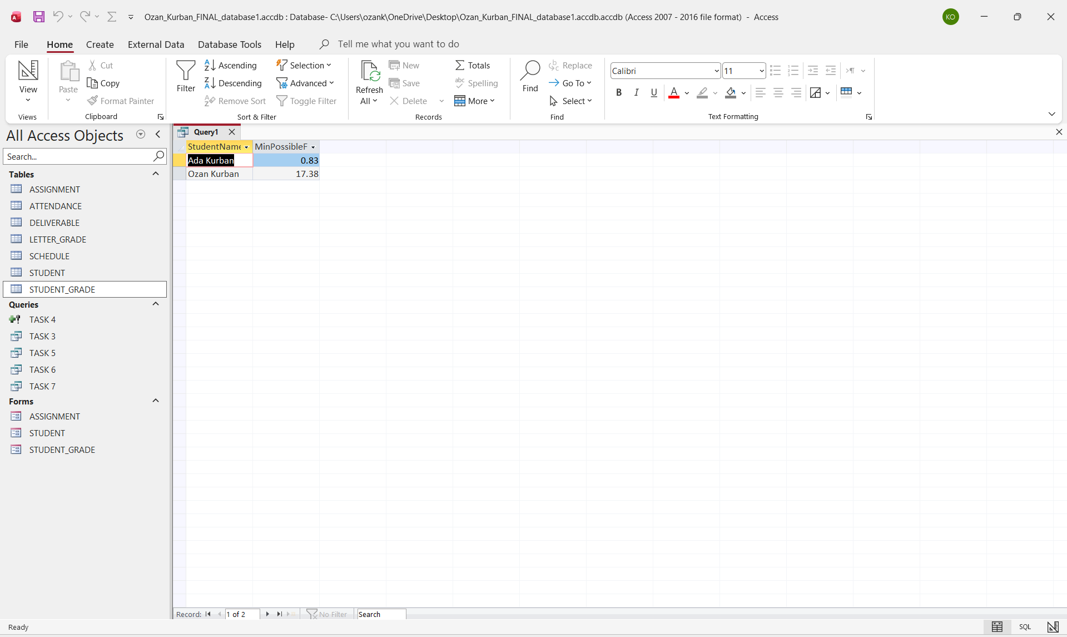

TASK 6:Maximum Grade Analysis
Estimate the best possible final grade if all pending deliverables receive a perfect score.
Instructions
- Assign 100 for all ungraded deliverables.
- Reuse Final Grade query logic.
- Compute each student’s maximum possible final grade.
Output
Student Name | Maximum Possible Final Grade
Submission
- Part A – SQL Code
- Part B – Results Table
SELECT
S.FirstName & ' ' & S.LastName AS StudentName,
ROUND(
SUM(
(
IIF(
SG.Score IS NULL
OR SG.Score = 0,
100,
SG.Score
),
100
) * A.Points_per_one
) / (
SELECT
Max(Max_Grade)
FROM
LETTER_GRADE
),
2
) AS MaxPossibleFinalGrade
FROM
(
(
STUDENT AS S
LEFT JOIN STUDENT_GRADE AS SG ON S.StudentID = SG.StudentID
)
LEFT JOIN DELIVERABLE AS D ON SG.DeliverableID = D.DeliverableID
)
LEFT JOIN ASSIGNMENT AS A ON D.AssignmentID = A.AssignmentID
GROUP BY
S.FirstName,
S.LastName;
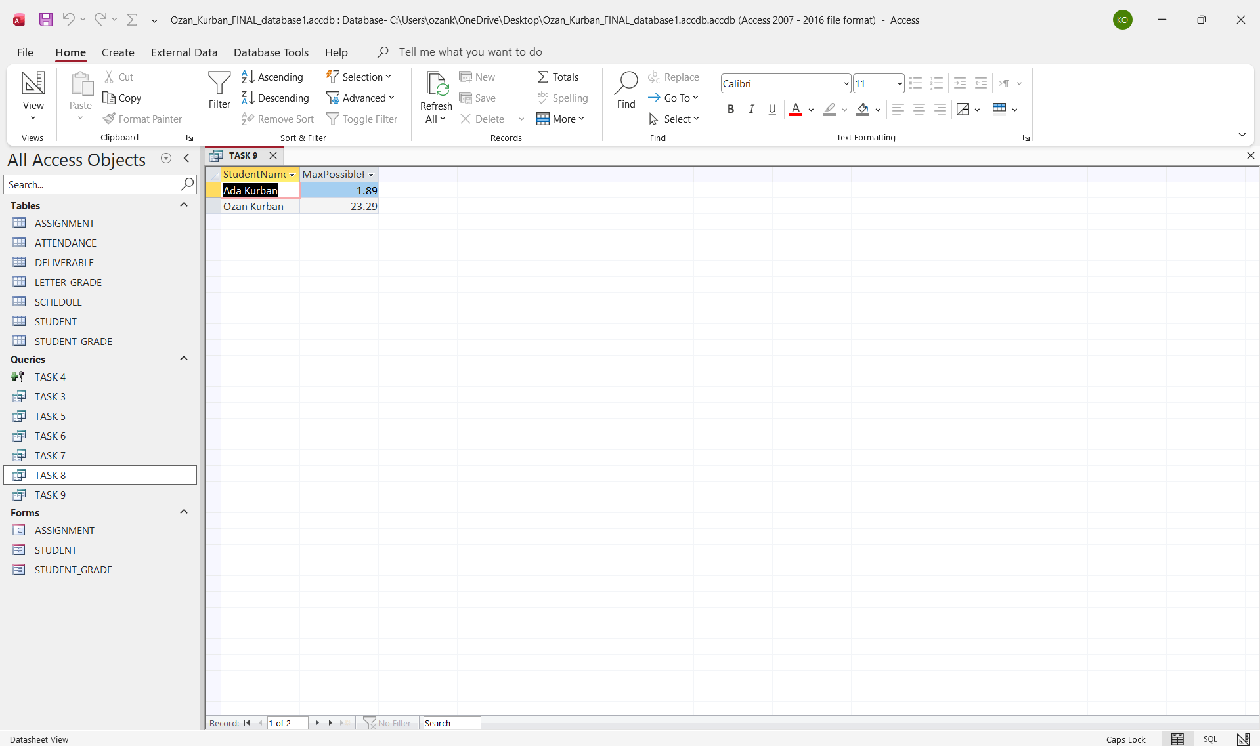
TASK 7:Macro Development and Automation
Develop macros to automate grade calculation and report generation.
Instructions
Macro 1: Calculate Final Grades & Letter Grades
- Purpose: Automates calculation and update of all grades.
- Functionality:
  - Runs Final Grade and Letter Grade queries.
  - Refreshes all relevant tables.
  - Ensures results stay current with one click.
- Name: Calculate_Final_And_Letter_Grades
Macro 2: Generate Grade Reports
- Purpose: Automates export of updated grade summaries.
- Functionality:
  - Calculates your MAXIMUM final grade.
  - Calculate your corresponding letter grade
  - Generate a report with all students' names, final grades and letter grades.
- Enhancement: Enables instant professional report generation.
Submission
- Part A – Macro Descriptions (2–3 lines each)
- Part B – Macro Designer Screenshots
- Part C – Outcome Screenshots (macros in action)

Macro Descriptions
Macro 1: Calculate_Final_And_Letter_Grades
This macro automatically updates all students’ final grades and letter grades. It runs the Final Grade and Letter Grade queries in sequence and refreshes the related tables to ensure that all grade calculations remain current. With one click, all grade results are recalculated and updated.
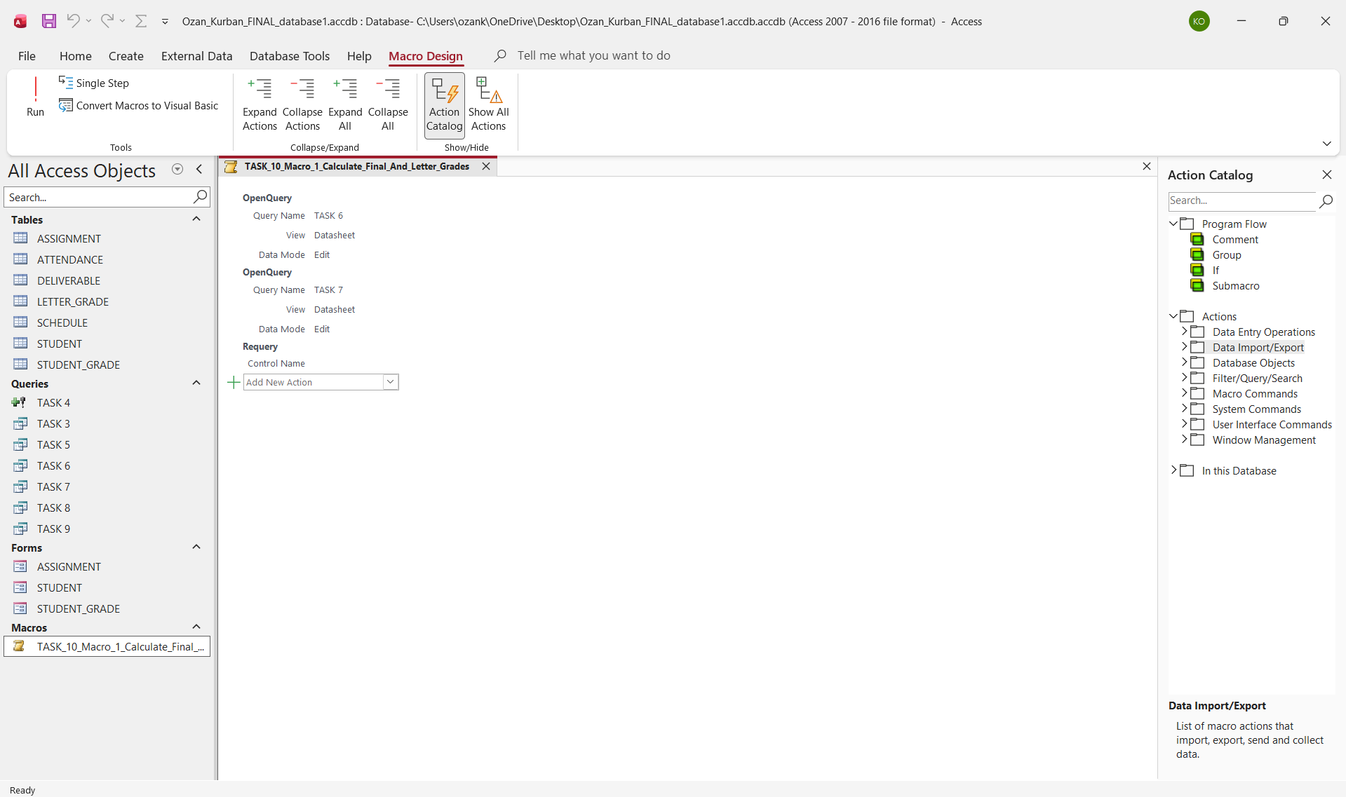

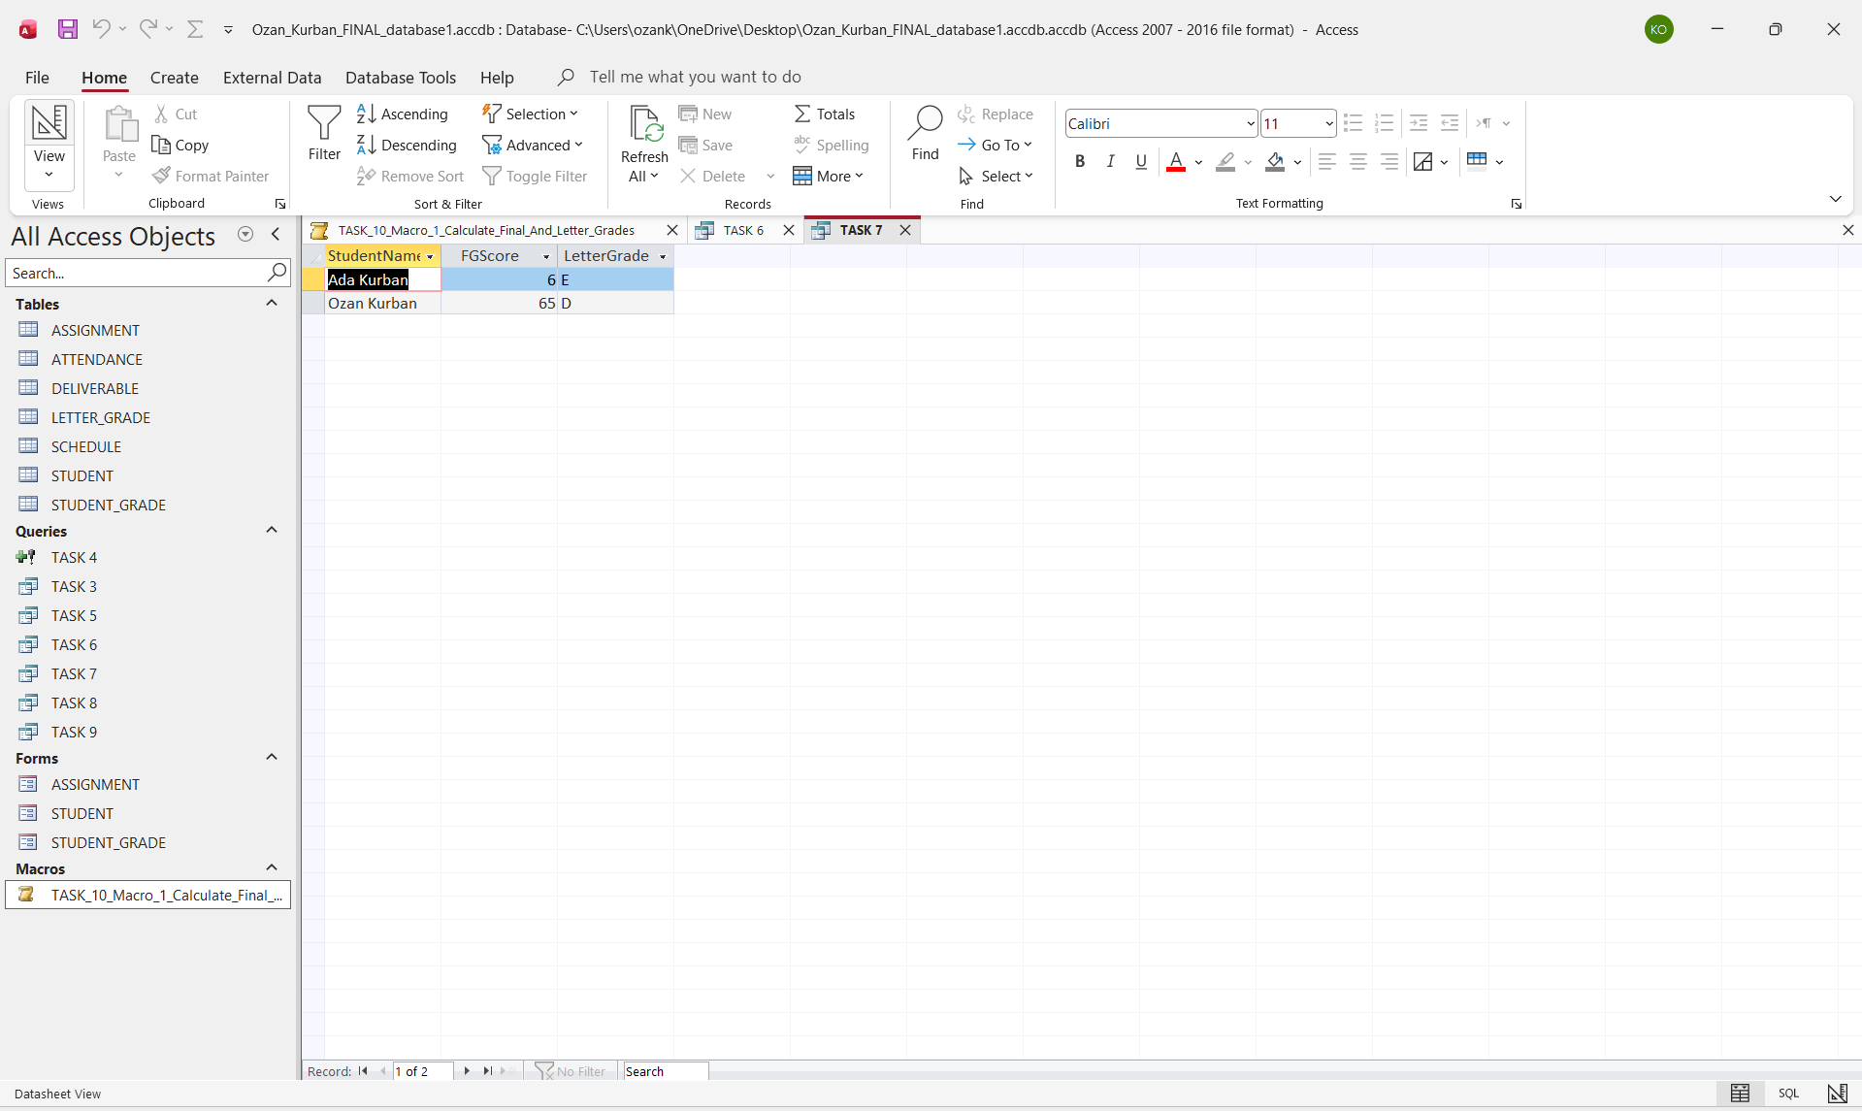

Macro 2: Generate_Grade_Reports
This macro calculates each student’s maximum possible final grade and determines the corresponding letter grade. It then generates a report containing all students’ names, final grades, and letter grades, and exports the updated report automatically. The macro enables quick, accurate, and professional report generation.
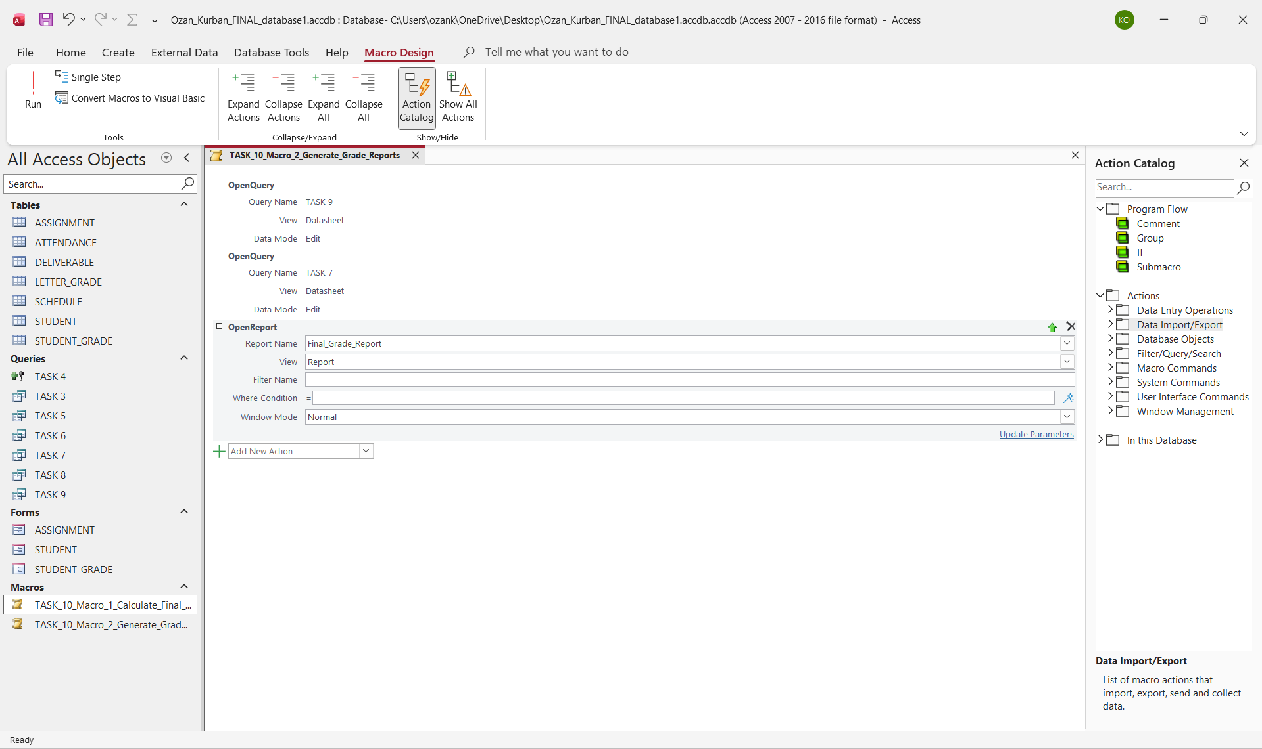
For create a report:
SELECT
T6.StudentName,
T6.FinalGrade,
T7.LetterGrade
FROM
[TASK 6] AS T6
INNER JOIN [TASK 7] AS T7 ON T6.StudentName = T7.StudentName;

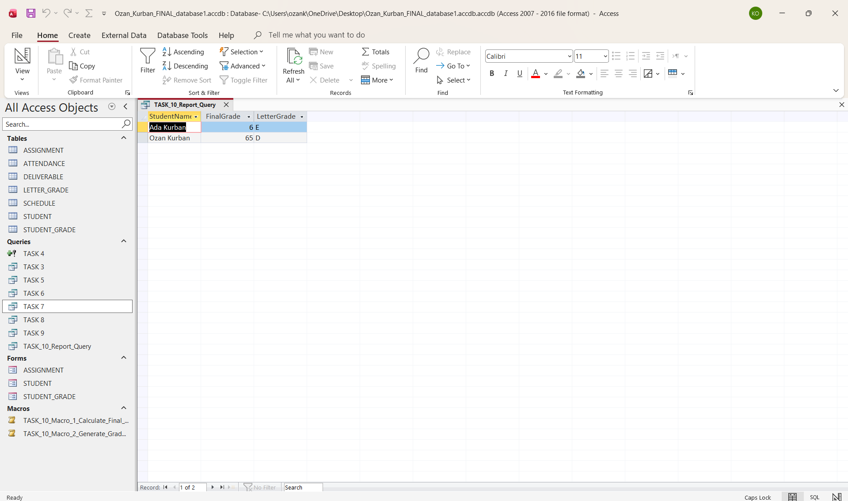
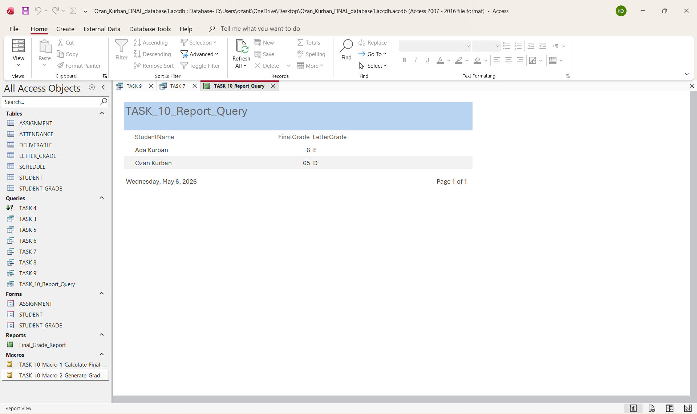

Database Administration (DBA) Functions
Identify and describe three key DBA functions to maintain your grading database.
Examples
- Concurrency Control: Ensures accurate simultaneous access for multiple users.
- Security Management: Protects confidential student data through permissions and passwords.
- Backup and Recovery: Enables database restoration in case of data loss or corruption.
Submission
Provide 1–2 paragraphs per function describing Purpose, Implementation Details, and Expected Outcomes:
Concurrency control is vital because it ensures that when multiple users access or update the grading database at the same time, the stored data remains accurate and consistent. Without these proper controls, simultaneous edits could override each other, leading to incorrect grades or incomplete records. In Microsoft Access, this is typically handled using record-level locking, which locks only the specific record being edited rather than the entire table. This prevents conflicts when two users attempt to modify the same grade, and as a result, grade entries remain reliable, data conflicts are minimized, and the overall integrity of the database is maintained even in multi-user scenarios.
Furthermore, security management protects sensitive student information—such as names, grades, and attendance—from unauthorized access. Effective security ensures that only approved users, such as instructors or administrators, can view or modify academic records. Security in Access can be implemented through password protection, encryption, user-level permissions, and restricting write access to specific individuals. Additionally, storing the database in a protected network location adds an extra layer of security. These measures help prevent data leaks, accidental changes, or unauthorized manipulation of grades, ensuring the confidentiality and integrity of all student records.
Finally, backup and recovery protect the grading database against data loss caused by corruption, accidental deletions, hardware failures, or user mistakes. A reliable backup strategy ensures that all academic data can be restored quickly when needed. In practice, this involves creating regular copies of the .accdb file, storing backups on cloud platforms like OneDrive, or maintaining versioned local backups. Recovery procedures allow the instructor to restore the database to a previous state with minimal disruption. The expected outcome is greater resilience: even if something goes wrong, all student grades, attendance records, and deliverables can be recovered without losing work.
Final Reflection and Learning Outcomes
Reflect on what you have learned about database design, automation, and analysis.
Learning Outcomes
- Design and document a relational database (ERD and SQL schema)
- Query and analyze performance data using SQL
- Automate database processes with macros
- Apply DBA principles (security, backup, integrity)
- Use BI concepts for actionable insights
Reflection Questions (250–300 words)
- What was the most challenging part of designing and managing your database?
- How did SQL, ERDs, and macros change your understanding of data systems?
- How can these skills apply to real-world business or education settings?
- What new questions or ideas about data and BI emerged for you?
- What were the strengths and what were the weaknesses of this class?
- What would you suggest as improvements for future semesters?
Designing and managing this database was a transformative experience that highlighted the complexity of structuring raw data into meaningful information. The most challenging aspect was ensuring the logical integrity of the Entity Relationship Diagram (ERD), particularly defining the cardinality and participation constraints between the STUDENT, ATTENDANCE, and STUDENT_GRADE tables. Mapping out how a single student relates to multiple attendance records and various deliverables required a deep understanding of database normalization to prevent data redundancy while maintaining accuracy.
Working with SQL, ERDs, and macros fundamentally shifted my understanding of data systems from static spreadsheets to dynamic, interconnected environments. Using SQL to translate a conceptual design into a functional MS Access schema taught me how specific data types, like COUNTER for primary keys and YESNO for attendance, dictate system behavior. Furthermore, developing macros like Calculate_Final_And_Letter_Grades demonstrated that automation is not just a convenience but a necessity for maintaining real-time accuracy in any professional data environment. These skills are directly applicable to business and education settings, where automating performance reports and securing sensitive student or client data through DBA principles is a standard requirement.
Reflecting on the course, the primary strength was the instructor's highly effective teaching style; the material was presented with a positive and engaging energy that made complex database concepts much easier to grasp. However, I believe the curriculum could be even more impactful with a heavier focus on hands-on coding and advanced SQL syntax. Additionally, moving to an online format would better align with the digital nature of the tools we use, such as Lucidchart and MS Access. These improvements would provide future students with a more streamlined and technically rigorous learning experience that mirrors the remote and code-heavy demands of the modern tech industry.

